**GOLDEN WEST HEALTH PLAN, INC**

**DENTAL PLANS HMO**

**HOW TO FILE AN ELECTRONIC GRIEVANCE**

Member may submit their own grievance form or a provider may do it on behalf of the member with their permission

Golden West Dental Website: <http://www.goldenwestdental.com/>

Click on Member Area: <http://www.goldenwestdental.com/member/index.html>

Then Click on “Grievance Form”:

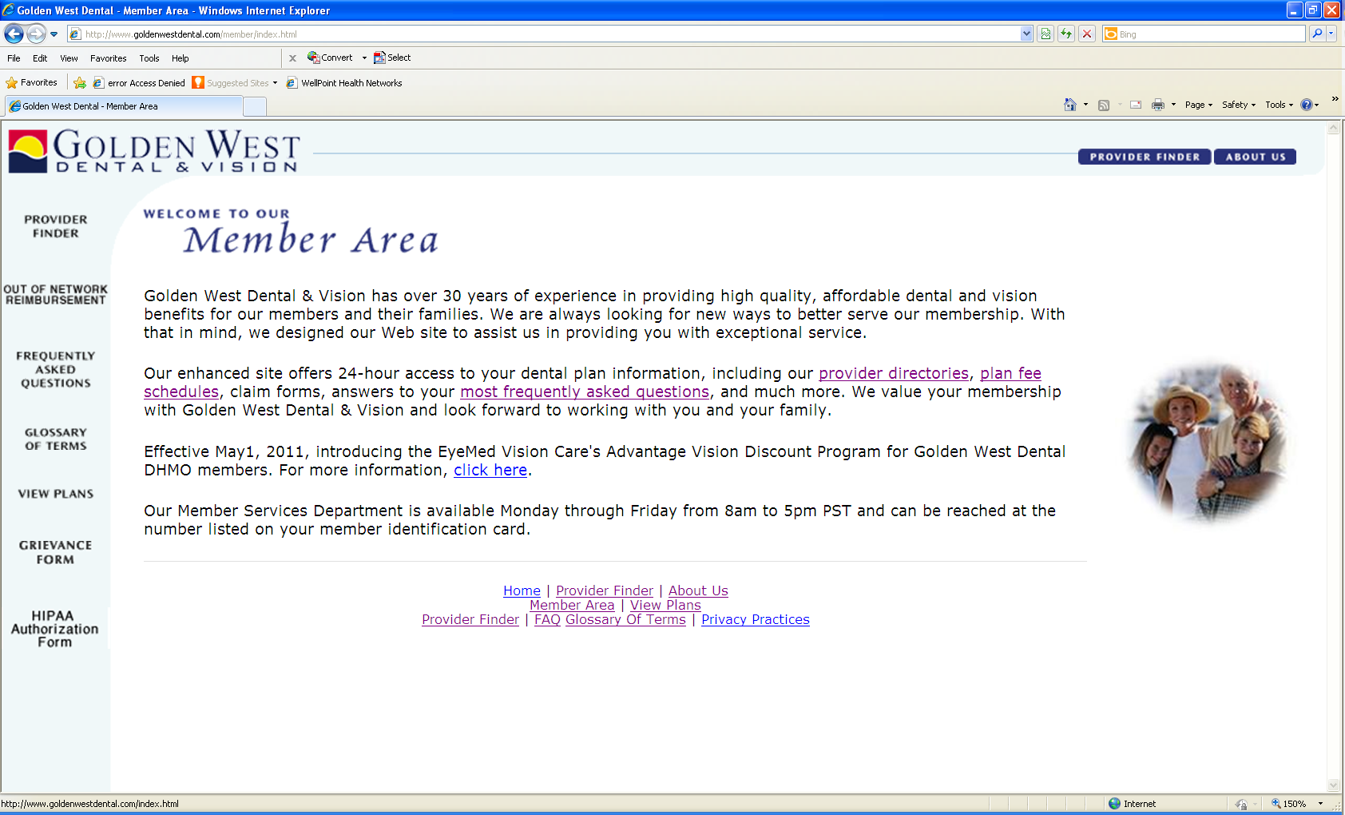

Automatically the Patient Grievance Form Secure Website is linked: <https://www.goldenwestdental.com/member/grievance.cfm>

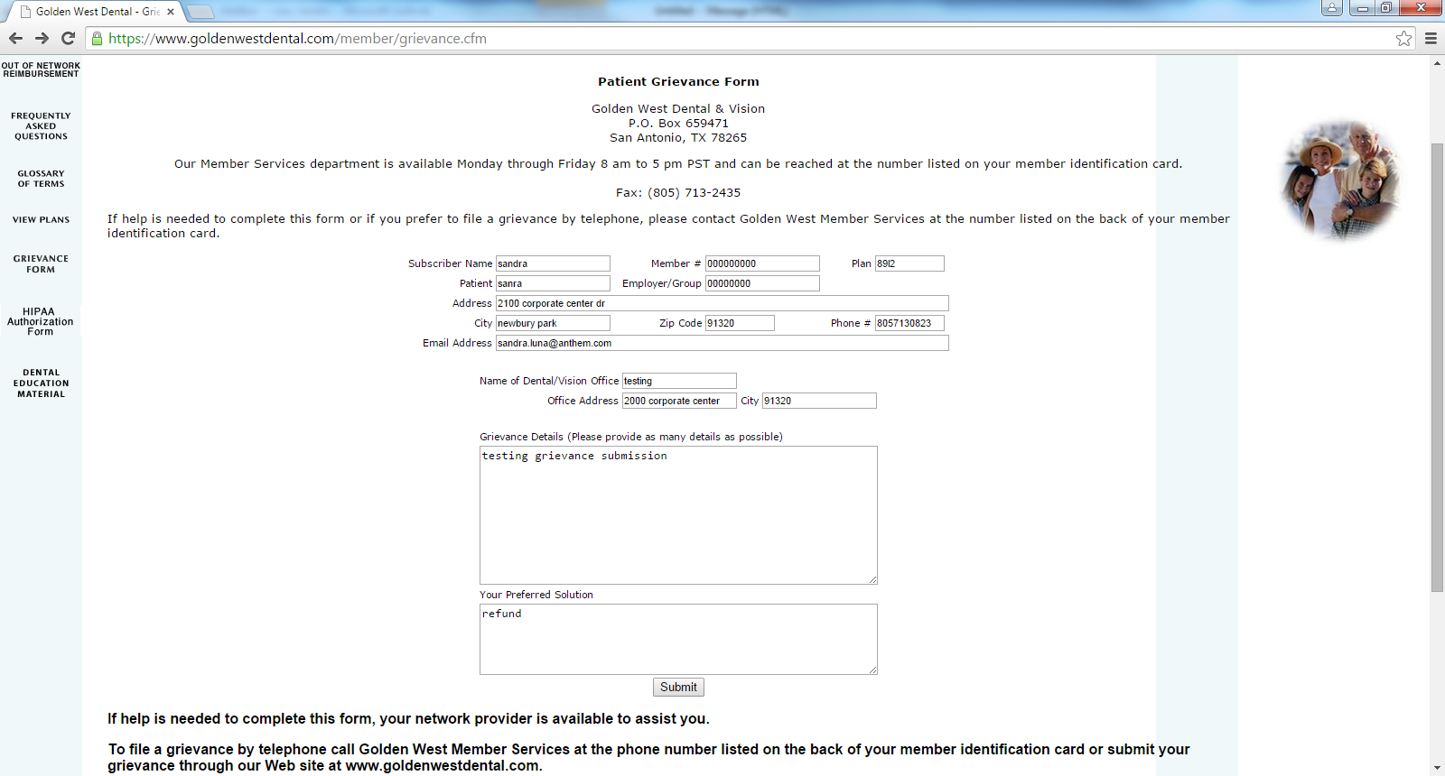

Member or Provider completes each box including grievance details and preferred solution.

Then click “Submit” button

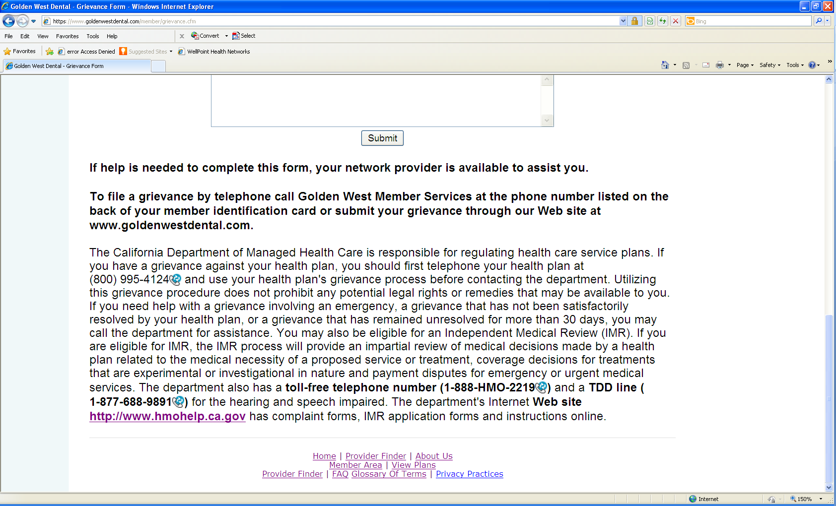

Sample of a Patient Grievance Form:

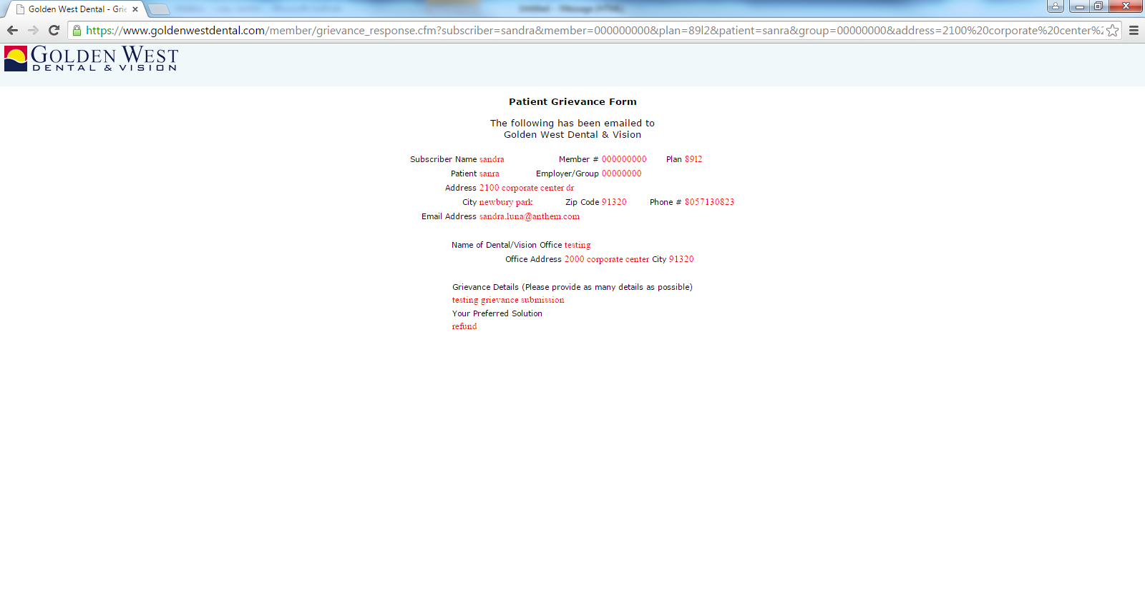

Grievance form is submitted secured to the Grievances and Appeals Department Shared email box: [DentalGrievance&Appeals@Wellpoint.com](mailto:DentalGrievance&Appeals@Wellpoint.com)

Email references web site grievance information inputted by the member on the web site including the same date and time of the submission date and time:

Email received by DentalGrivances&Appeals shared email box of Sample Grievance above:

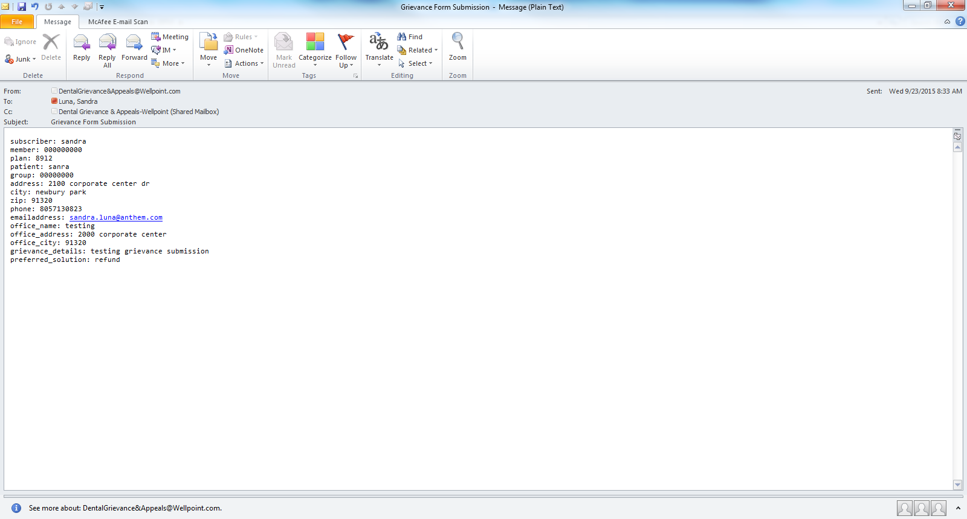

Grievances and Appeals Lead Analysts forwards to G&A Analyst next business day to begin the process